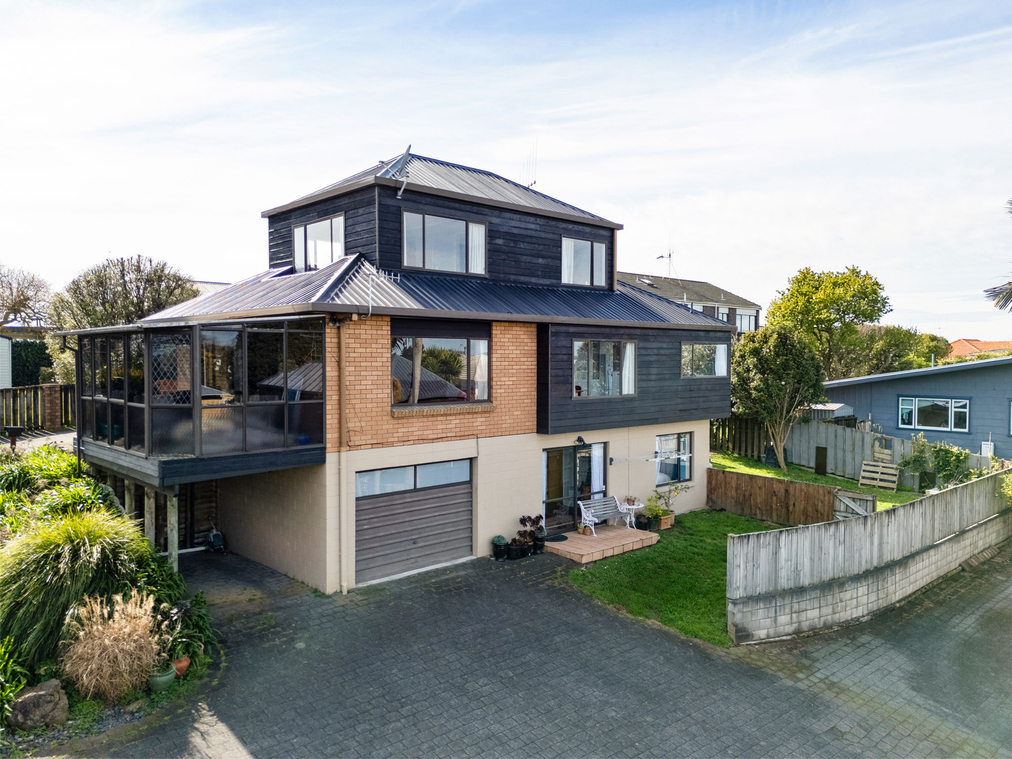
49C CAREY STREET
MAEROA | HAMILTON
SPACE FOR WHAT'S NEXT
280m² | 4 Bedrooms | 3 Bathrooms | 3 Living Areas | 2 Garages
ENQUIRIES OVER $910,000 | PRIVATE SALE

A Home With Options
Tucked away down a quiet lane with impressive mountain views and birdsong, this substantial 280m² home offers the space and separation that growing families often struggle to find.
Across three generous levels are four bedrooms, an office, three bathrooms, three living areas and two garages. The layout works particularly well for multi-generational living, teenagers, extended family, guests or working from home - while still feeling like one connected family home.
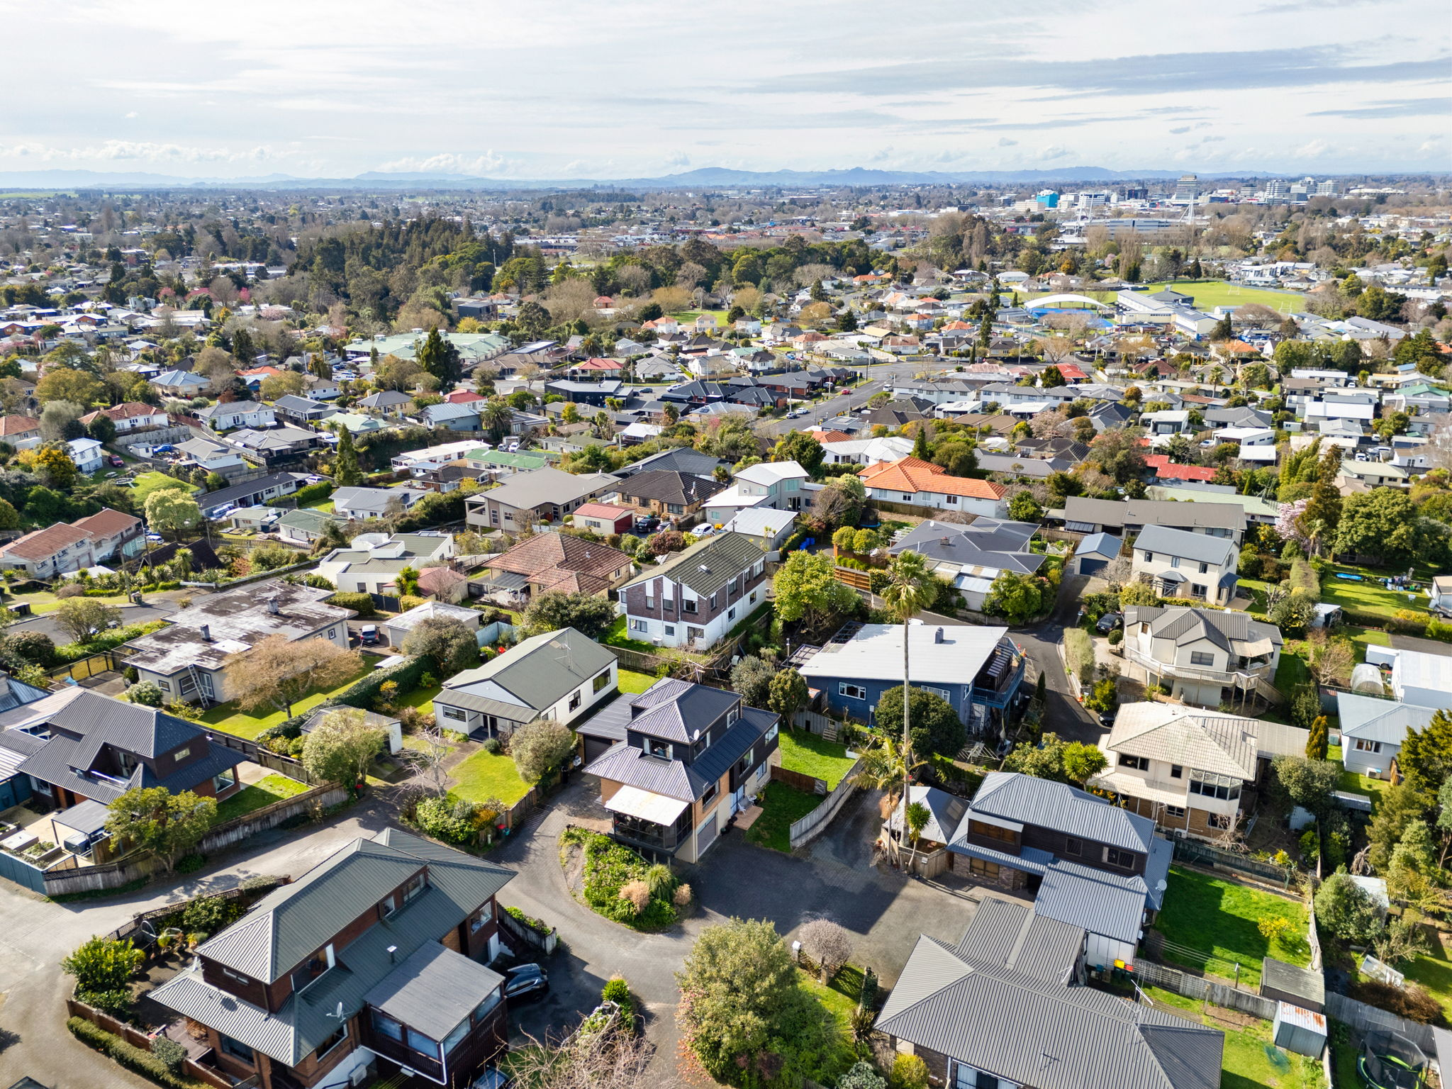 | 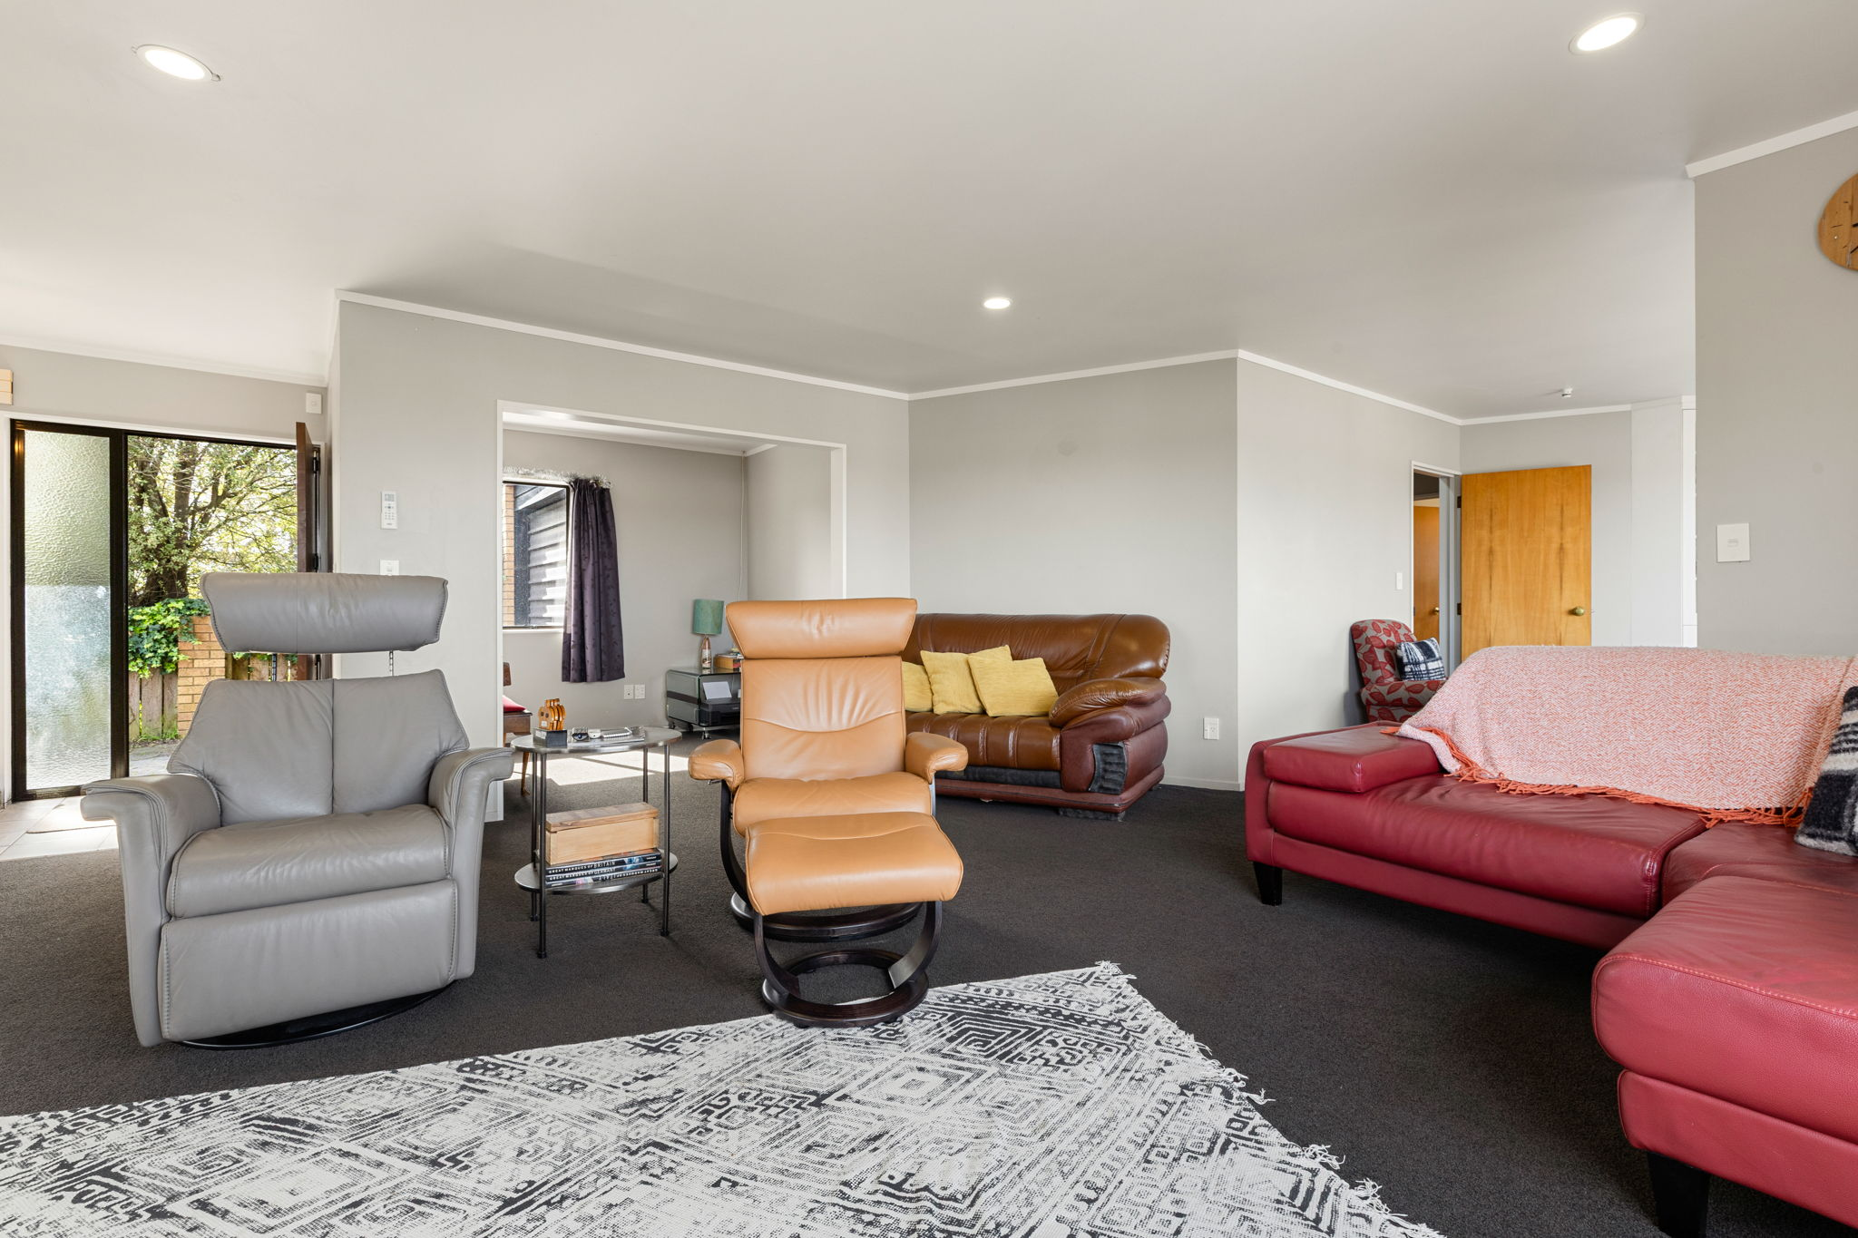
280m² | 4 | 3 | 3 | 2
Approx. floor area | Bedrooms | Bathrooms | Living areas | Garages

Living, Entertaining & Outlook
Generous everyday living spaces give the household room to come together, while the kitchen, dining and outdoor areas make the most of the home's elevated position.
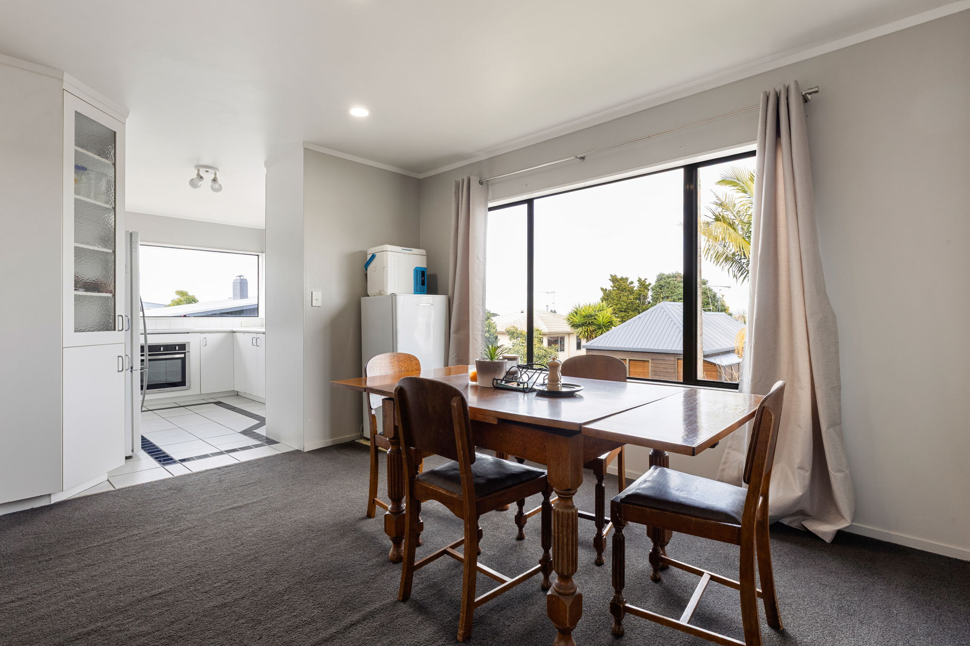 | 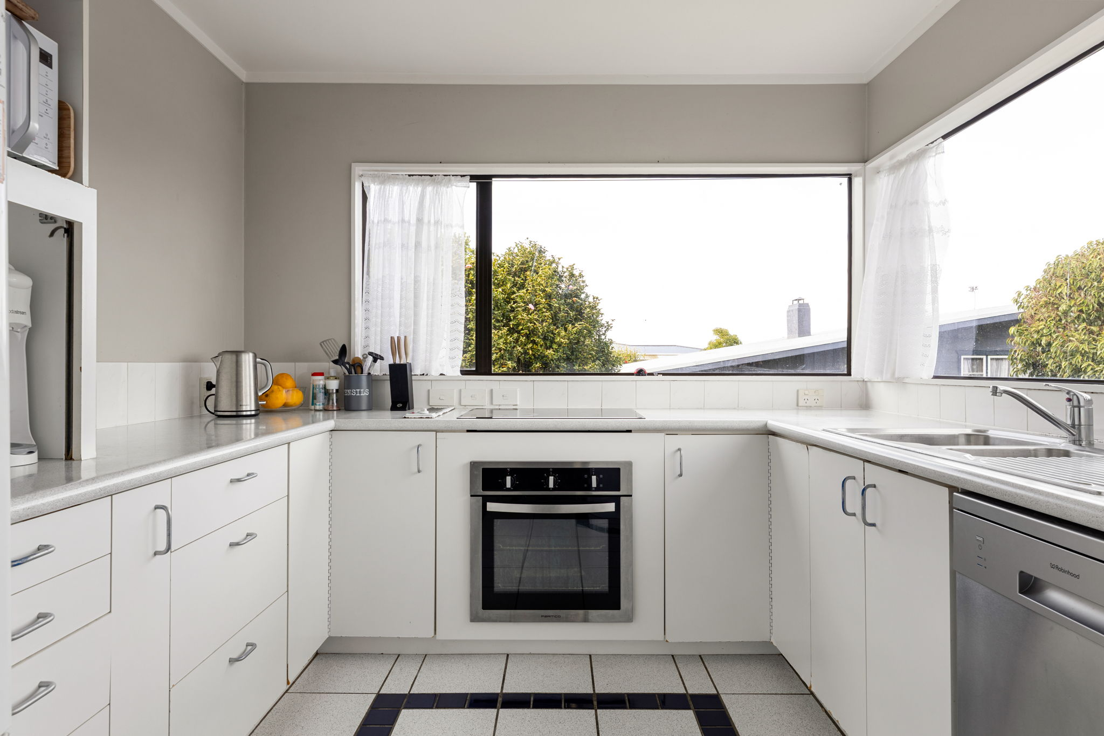
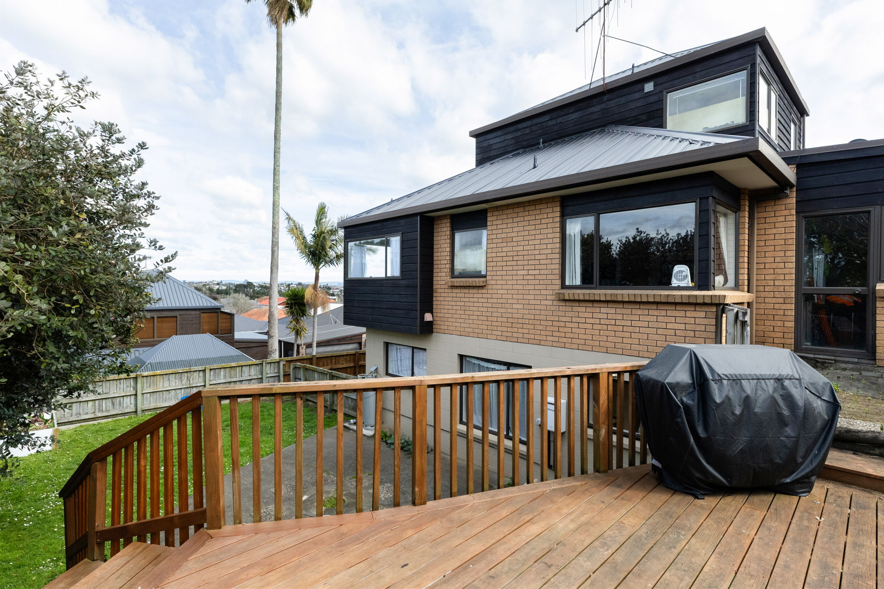
Quiet lane setting | Elevated outlook | Mountain views | Backyard space

Space for Everyone
Bedrooms are spread across the home, creating useful separation for family members, guests or home-based work. The upper level provides two bedrooms and a full bathroom, while the main level includes a large bedroom, bathroom and office.
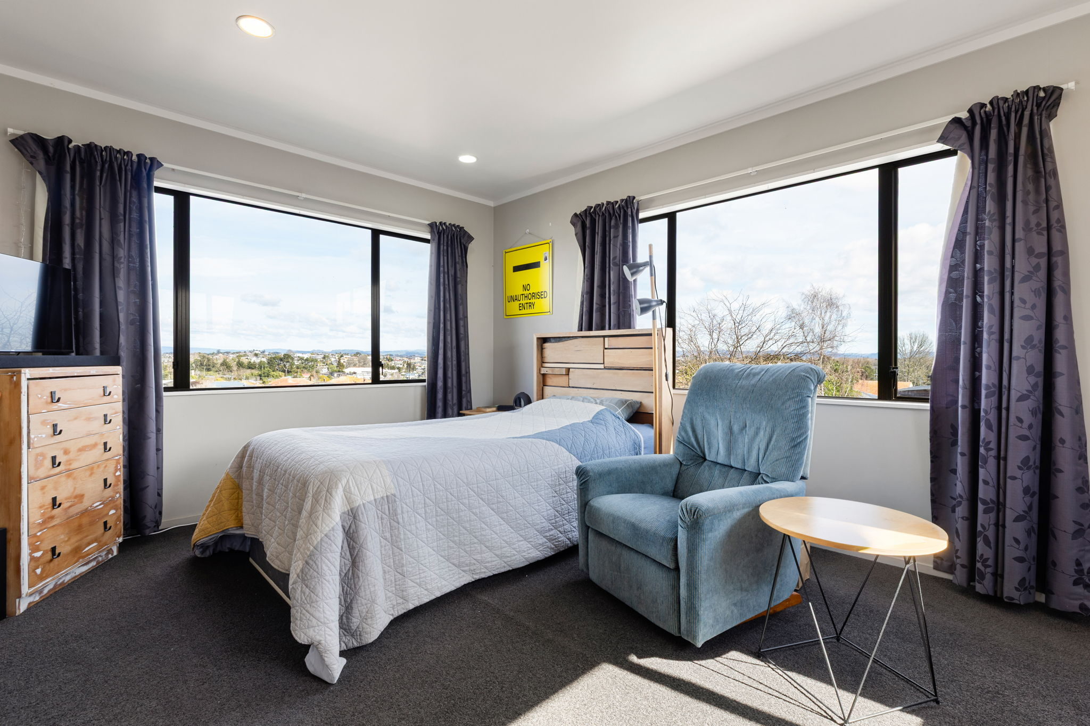 | 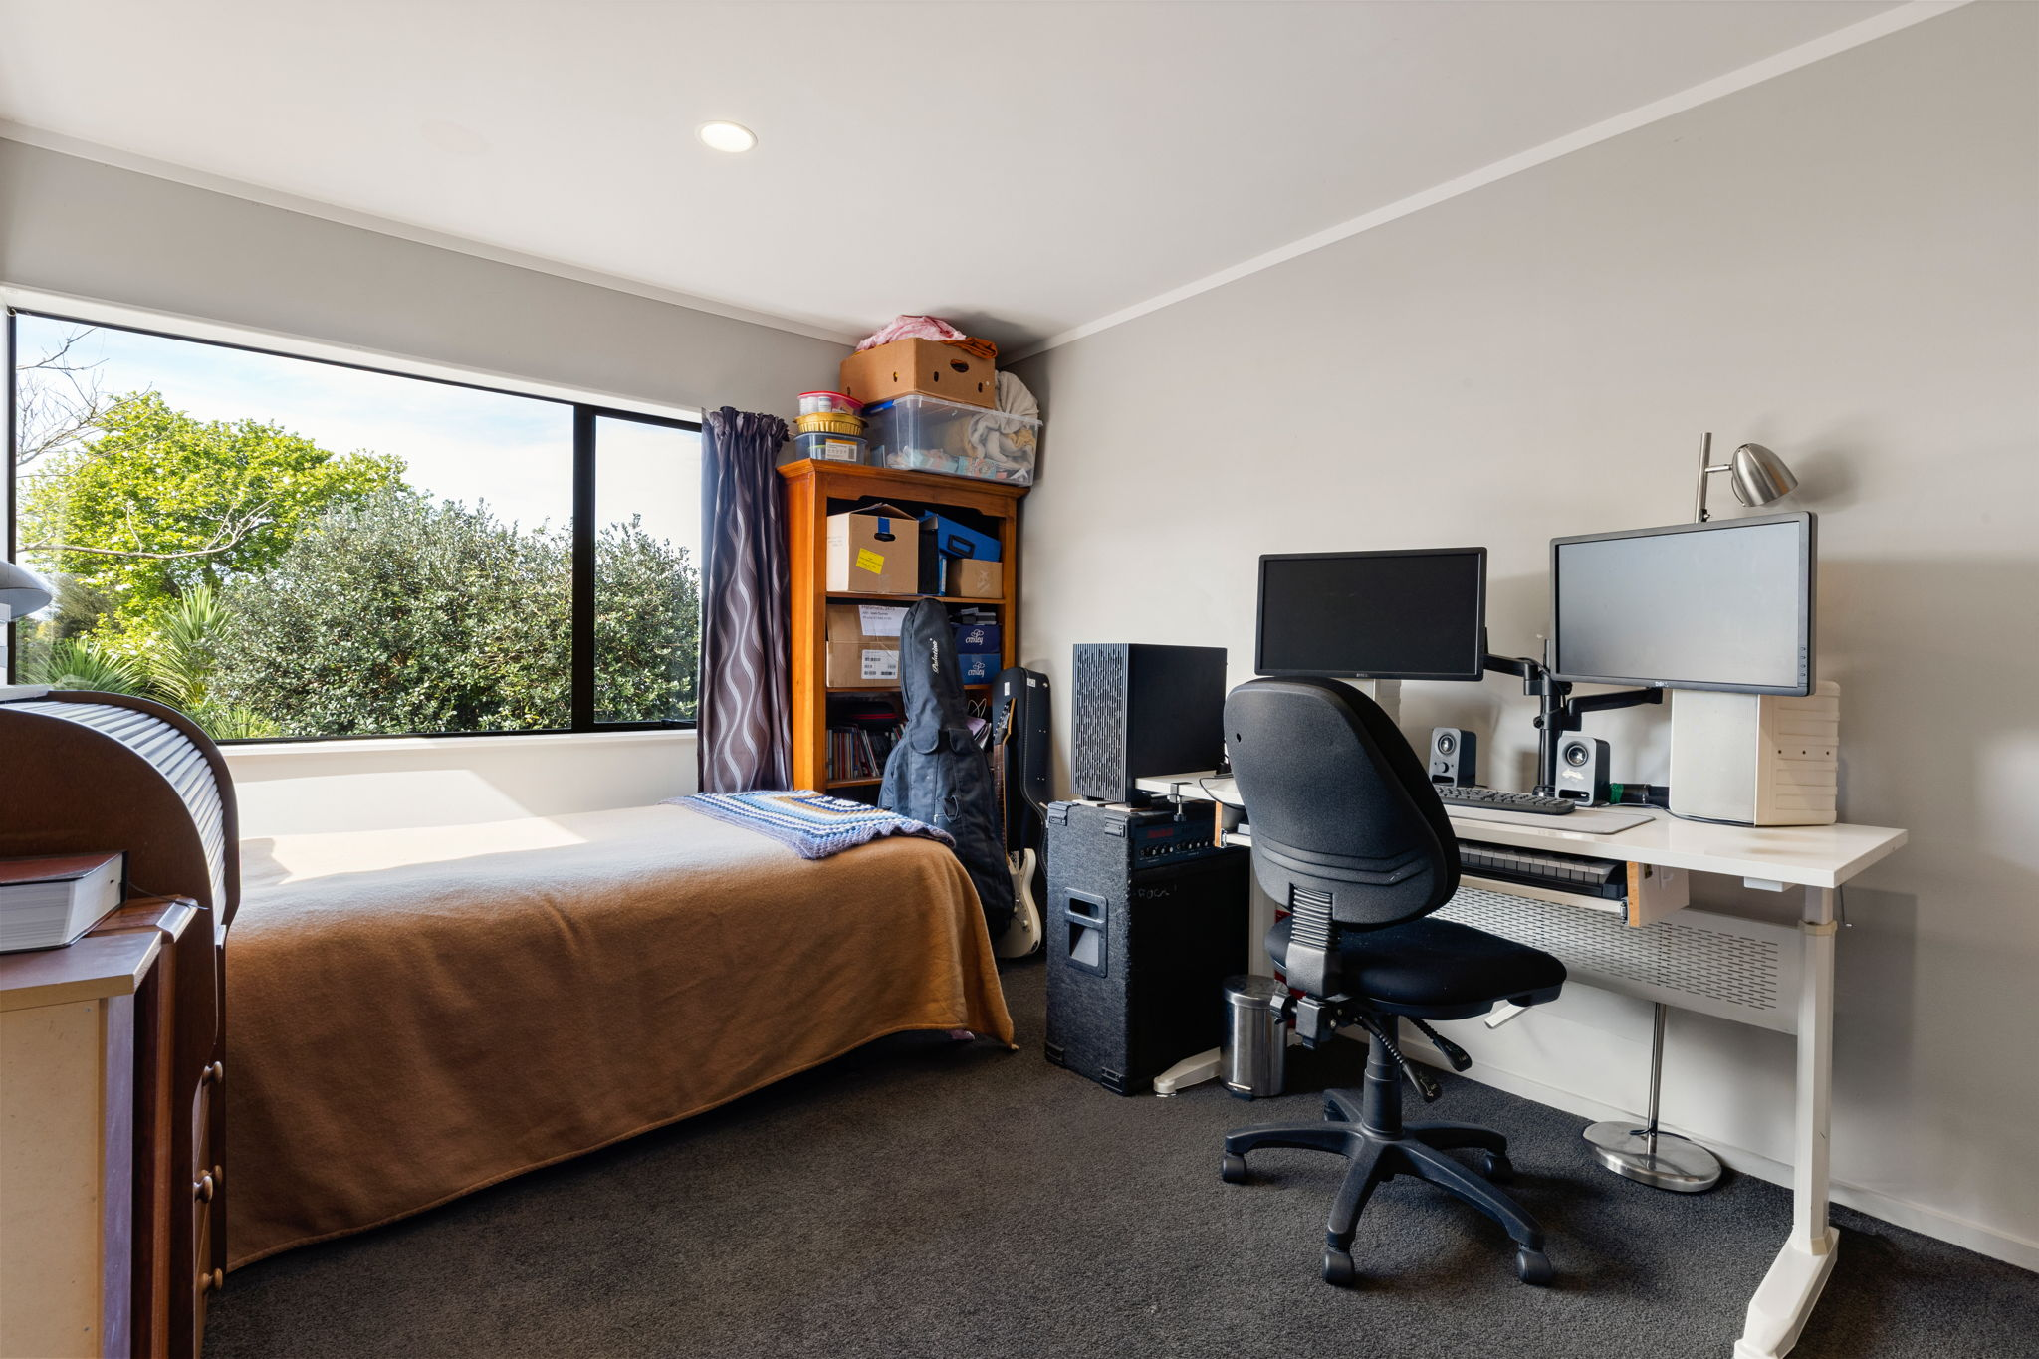

Flexible Lower Level
The lower level adds another useful dimension to the home, with a bedroom, living/recreation space, bathroom, kitchenette area, separate entrance and garage. It provides valuable flexibility within the home's overall three-level layout.
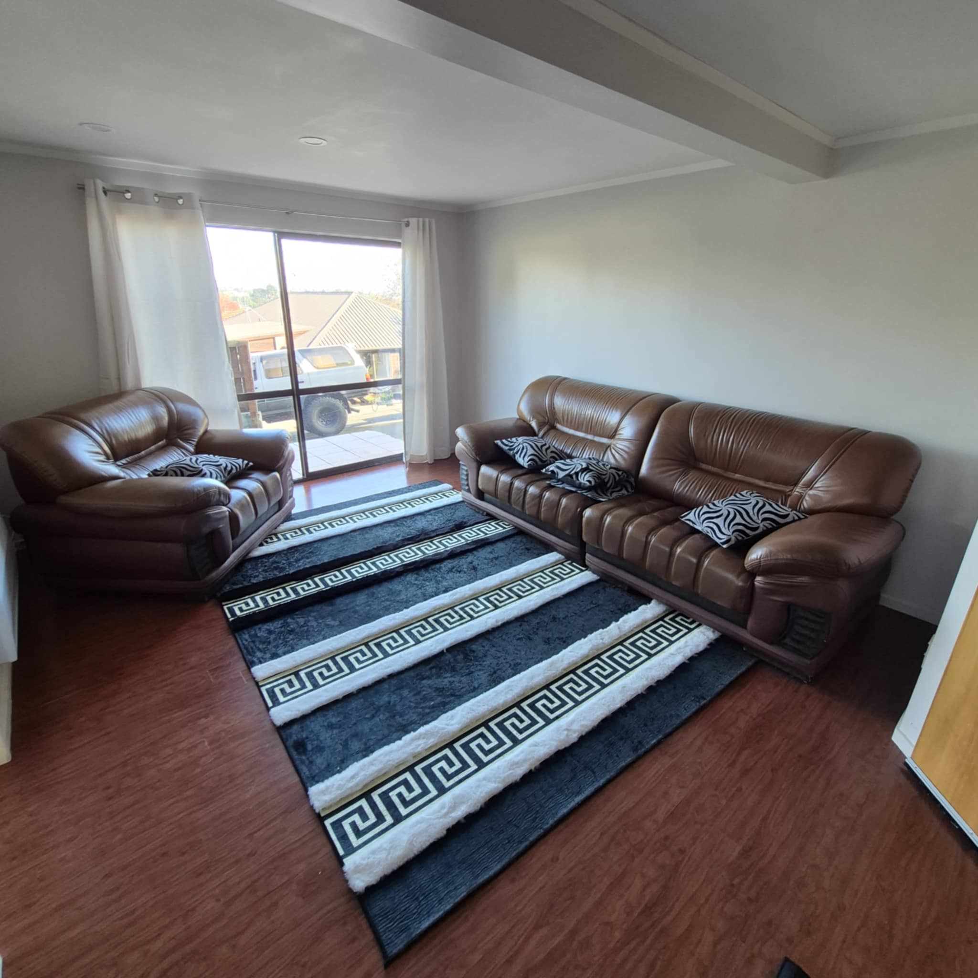 | 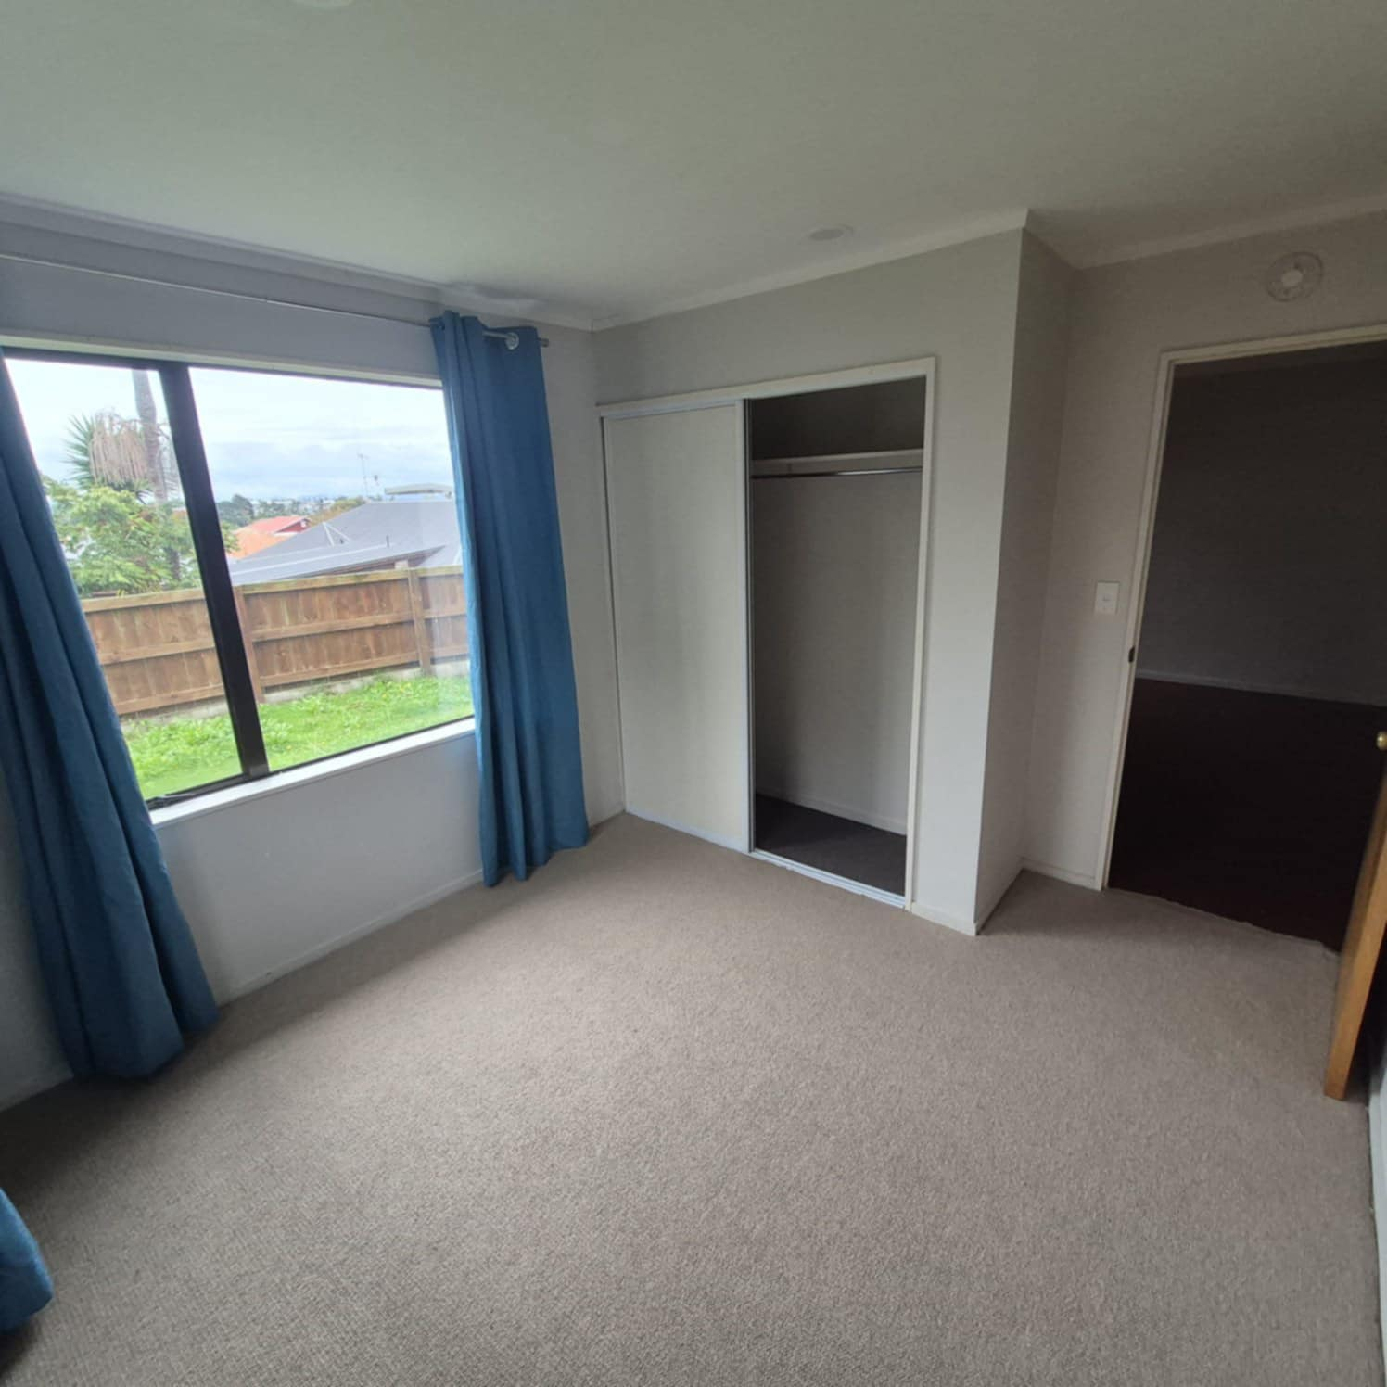
Note: The lower level is presented as part of the home's flexible accommodation. Buyers should review the available property information and satisfy themselves as to matters important to their intended use.

One Home. Three Generous Levels.
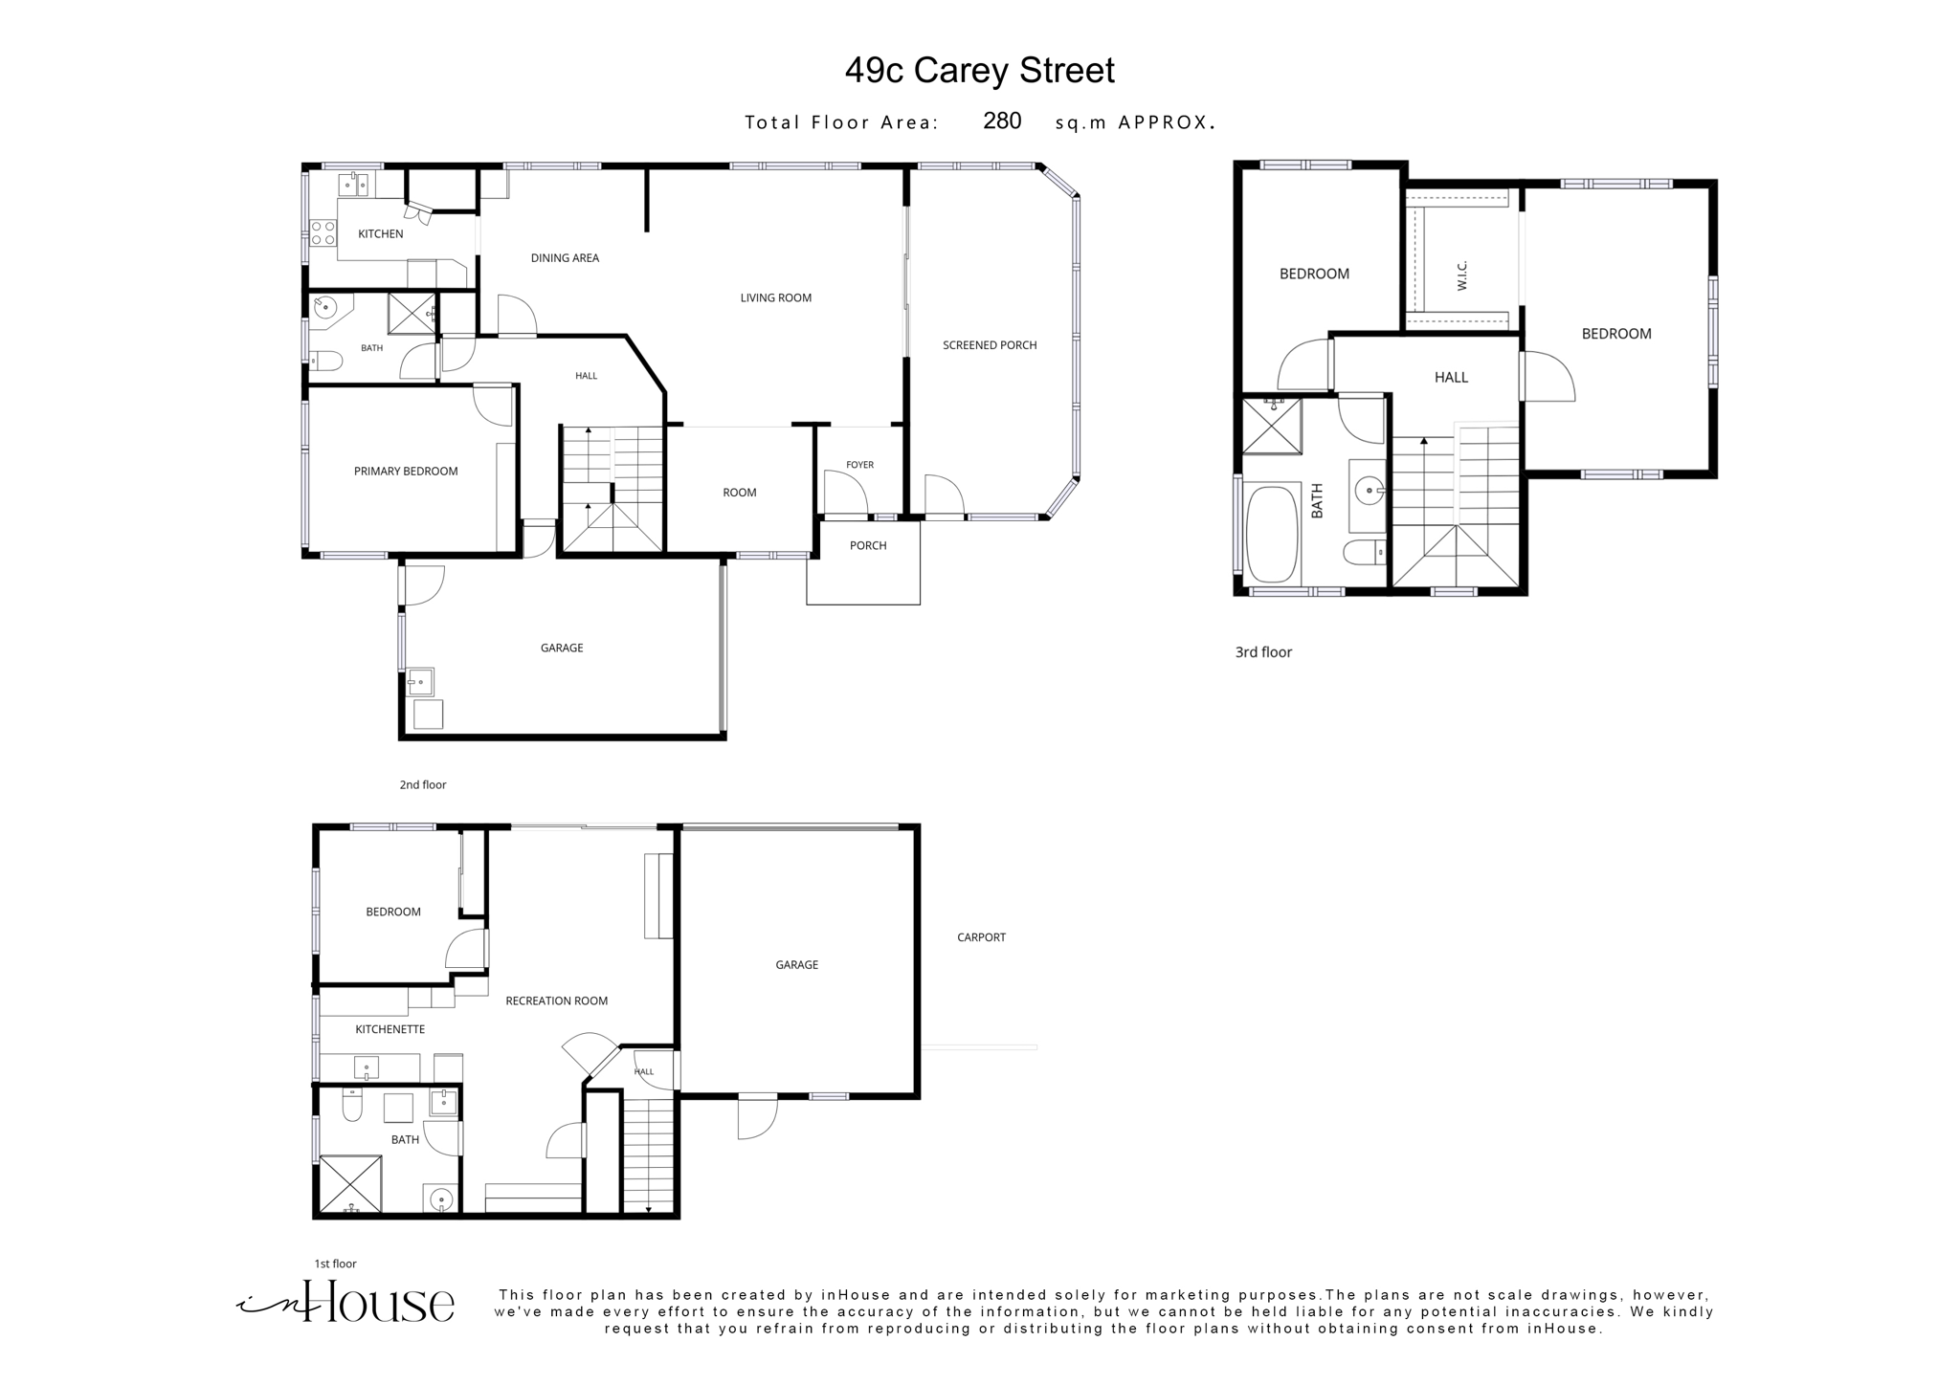
The floorplan illustrates the current layout and is intended for marketing purposes. Buyers should undertake their own due diligence regarding dimensions, title and permitted use.

A Strong Foundation
The home is established and functional, with recent maintenance and improvements providing a solid base for the next owner while still leaving scope to personalise selected areas over time.
Recent Improvements | Future Opportunity
New deck  Roof resealed  Weatherboards restained  New downstairs flooring | Bathrooms are fully functional but dated, offering an opportunity to modernise over time.

Council & Property Information
A Hamilton City Council LIM dated 4 July 2024 is available to prospective purchasers, together with relevant property documentation. Purchasers are encouraged to review the information provided and undertake their own due diligence.
49C Carey Street is held under a residential cross-lease title. The separate Property Information Sheet and available property documents provide further information for prospective purchasers.

Maeroa Living
Positioned in established Maeroa, the property combines a peaceful residential setting with convenient access to Hamilton CBD, The Base, local schools, shopping, parks and major transport routes.
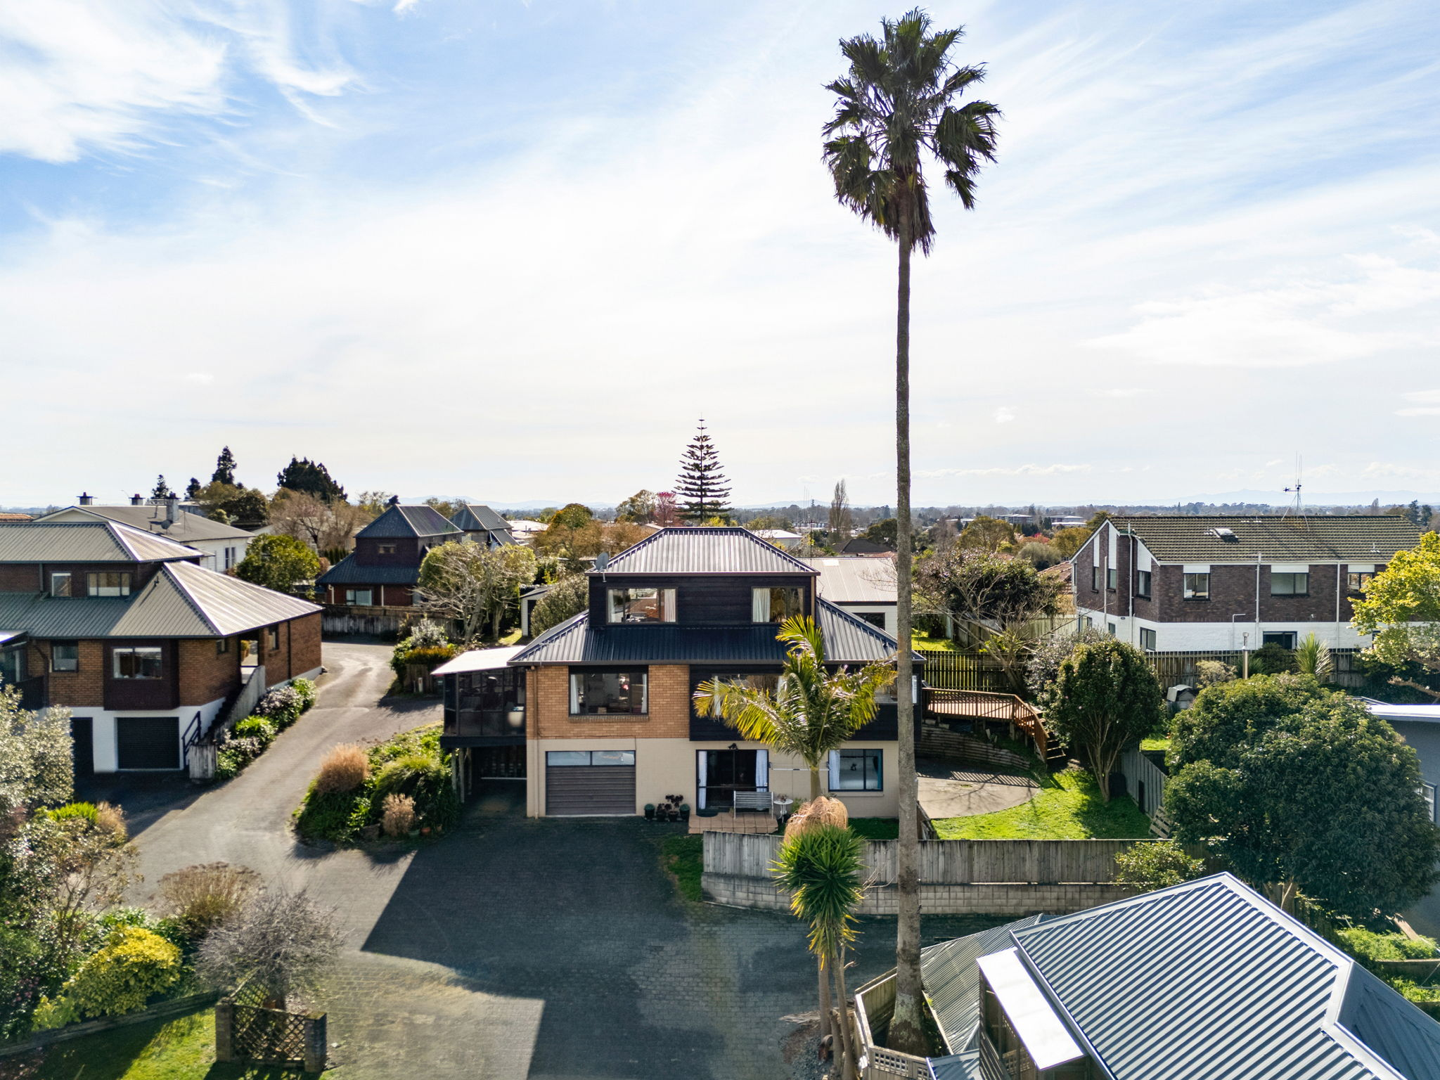

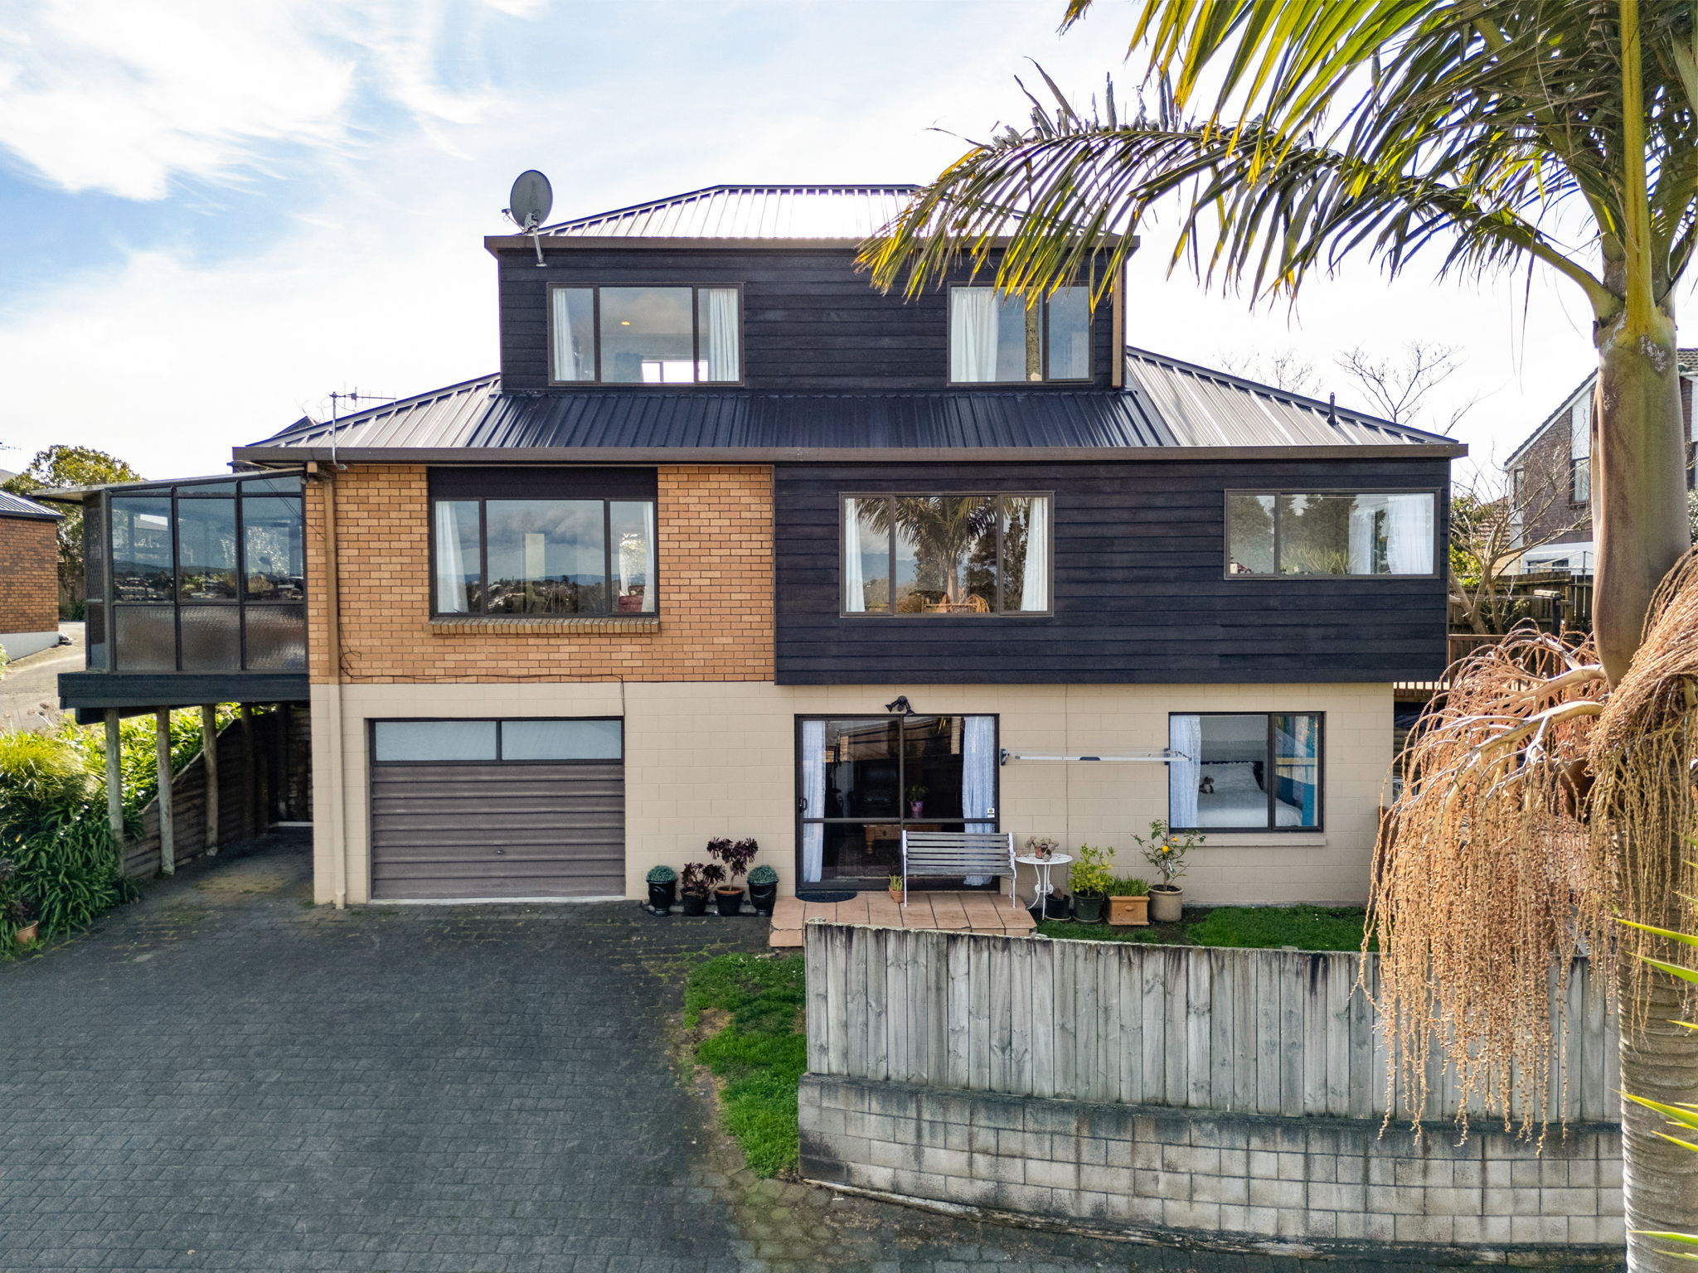
A HOME WITH SPACE FOR WHAT'S NEXT
4 bedrooms | 3 bathrooms | 3 living areas | 3 levels | 2 garages

ENQUIRIES OVER $910,000
PRIVATE SALE | VIEWINGS BY APPOINTMENT
Gretta Fleming 0272517285 grettarjolly@gmail.com

The vendor reserves the right to accept an offer at any time. Final sale terms are to be recorded in the sale and purchase agreement.

